SIMATS ENGINEERING (SAVEETHA SCHOOL OF ENGINEERING)
Department of Computer Science & Engineering ASSESSMENT TOOL 1 – APPLICATION BASED QUESTIONS

Course Code | CSA4315 | Course Title | Internet Programming
CO Assessed | CO1 | Assessment | Assessment Tool 1: Application Based Questions
Weightage | 40% of CIA | Total Marks | 100
CO1 Statement | Explain the fundamentals of web architecture, client-server communication, Internet protocols, HTTP request and response messages, and configure LAMP/WAMP environments for web application development and deployment. (BL3)
Student Name | D N SHIRSHIKA | Reg. No. | 192425396
Section/Batch | Slot D / 2024 | Date | 20-10-2026

D N Shirshika
Code of Conduct:
I,DN SHIRSHIKA certify that this submission is my original work and that I have adhered to the guidelines specified for this assessment. I understand that any violation of academic integrity rules will result in disciplinary action.
Signature of the student:

Question A developer installs WAMP on Windows but cannot access the website using http://localhost. Identify four possible causes and propose a solution for each

Solution:
Troubleshooting WAMP Server on Windows: Cannot Access Website Using http://localhost
1. Introduction
WAMP is a software package used to develop and test websites on a Windows computer. WAMP stands for Windows, Apache, MySQL/MariaDB, and PHP. It provides a local environment where developers can create, run, and test websites without publishing them on the internet.
When a developer installs WAMP and enters http://localhost in a web browser, the WAMP homepage should normally appear. However, sometimes the browser displays an error message, refuses the connection, or shows a blank page.
This problem may occur because Apache is not running, another application is using the required port, the Apache configuration is incorrect, or firewall and antivirus software are blocking the connection.
The following sections explain four possible causes and their solutions in detail.

2. Cause 1: Apache Server Is Not Running
Explanation
Apache is the web server component of WAMP. It receives requests from the browser and sends the requested website pages back to the user. When a developer enters http://localhost, Apache must be running to process the request.
Sometimes Apache does not start automatically after WAMP is installed. It may also stop because of a service error, a configuration problem, or insufficient permissions. If Apache is stopped, the browser cannot connect to the local website.
Symptoms
- The browser displays “This site can’t be reached.”
- The connection is refused.
- The WAMP tray icon may appear red or orange, depending on the service status.
- Apache may fail to start or stop immediately after starting.
Solution
- Open the WAMP application from the Windows Start menu.
- Wait for its services to initialize.
- Check the WAMP icon in the Windows system tray.
- Open the WAMP menu and select the Apache service controls.
- Start or restart Apache if it is stopped.
- If Apache fails to start, open the Apache error log and identify the reported problem.
- After Apache starts successfully, open the browser and enter http://localhost again.
If Apache continues to fail, check Windows Services to confirm whether the Apache service is running. Running WAMP with suitable administrator permissions may also help if permissions are the cause.
Problem | Solution
Apache service is stopped | Start Apache from the WAMP menu.
Apache fails to start | Check the Apache error log.
WAMP services are not initialized | Wait for startup and check the tray icon.
Permission error occurs | Run WAMP with appropriate permissions.
Expected result: Apache starts successfully, and the browser can access the local WAMP homepage.

3. Cause 2: Port 80 Is Being Used by Another Application

Explanation
Apache usually listens for HTTP requests on port 80. A port is a communication endpoint that allows applications to exchange network data.
If another application is already using port 80, Apache may not be able to use the same port. Applications such as Internet Information Services (IIS), another Apache installation, or another web server may create this conflict.
Even if WAMP is installed correctly, Apache may fail to start because the required port is unavailable.
Symptoms
- Apache does not start.
- The WAMP icon does not turn green.
- The Apache error log reports that it cannot bind to the address or port.
- Another local website appears instead of the WAMP homepage.
Solution
Step 1: Check whether port 80 is occupied.
Open Command Prompt and enter:
netstat -ano | findstr :80
This command displays network connections associated with port 80. Look for a line showing LISTENING and note the process ID (PID).
Step 2: Identify the application.
Open Task Manager and use the Details tab to find the process with the matching PID. Identify the application before stopping anything.
Step 3: Resolve the port conflict.
There are two possible solutions:
- Stop the conflicting application or service if it is not needed.
- Configure Apache to use another available port, such as 8080.
Step 4: Test the website.
If Apache has been configured to use port 8080, enter:
http://localhost:8080

The port number must match the Apache configuration.
Cause | Solution
IIS is using port 80 | Stop IIS if it is not required.
Another web server uses port 80 | Identify and resolve the conflict.
Apache is configured for port 8080 | Access http://localhost:8080.
Apache port settings are inconsistent | Correct the relevant configuration settings and restart Apache.
Expected result: Apache can listen on the configured port, and the website becomes accessible through the correct URL.

4. Cause 3: Incorrect Apache Configuration
Explanation
Apache uses configuration files to determine its listening ports, website directories, access permissions, and virtual-host settings.
If these configuration files contain incorrect settings or syntax errors, Apache may fail to start or may display the wrong website. An incorrect document root can also prevent the server from finding the website files.
For example, the website files may be stored in one folder while Apache is configured to look in another folder.
Symptoms
- Apache fails to start after a configuration change.
- The browser displays a 403 Forbidden or 404 Not Found error.
- An unexpected website appears.
- The WAMP homepage works, but the developer's own project does not.
Solution
Step 1: Open the Apache configuration file.
Use the WAMP menu to locate the relevant Apache configuration file, commonly named httpd.conf.
Step 2: Create a backup.
Save a copy of the configuration file before making changes. This allows the developer to restore the original settings if something goes wrong.
Step 3: Check the configuration.
Verify the following:
- The listening port is correct.
- The DocumentRoot points to the correct website folder.
- The folder exists on the computer.
- The configuration syntax is valid.
- Virtual-host settings, if used, are correct.
Step 4: Check the error log.
The Apache error log may identify the incorrect directive or configuration file. Correct the reported problem instead of changing unrelated settings.
Step 5: Restart Apache.
Save the corrected configuration, restart Apache, and enter http://localhost in the browser.
Configuration problem | Solution
Incorrect listening port | Set the correct available port.
Wrong document-root path | Point Apache to the correct website folder.
Syntax error in configuration | Correct the directive identified in the error log.
Incorrect virtual-host settings | Verify the hostname, port, and document root.
Access permissions are incorrect | Correct the relevant folder permissions and Apache access rules.
Expected result: Apache starts without configuration errors and serves the correct website.

5. Cause 4: Firewall or Antivirus Is Blocking Apache

Explanation
Windows Defender Firewall and third-party antivirus software help protect computers from unauthorized network connections. However, security software may sometimes block Apache if it is treated as an unknown application or if an existing rule points to an older WAMP installation.
In such cases, Apache may be running, but the browser may still be unable to connect to the local website.
Symptoms
- The browser displays a connection error or timeout.
- Apache appears to be running, but the connection fails.
- Security software displays a warning about Apache.
- The firewall contains an outdated rule for a previous installation.
Solution
Step 1: Check Apache status.
Confirm that Apache is running and listening on the expected port.
Step 2: Review firewall settings.
Open Windows Security and navigate to the firewall settings. Check the allowed applications and relevant firewall rules.
Step 3: Verify the Apache application.
If a rule is required, allow the correct Apache executable and use the appropriate network profile. Ensure that the rule applies to the current WAMP installation.
Step 4: Check antivirus notifications.
Review the antivirus protection history to see whether a legitimate Apache file has been blocked or quarantined.
Step 5: Test again.
Restart Apache if needed and open http://localhost in the browser.
Do not permanently disable the firewall or antivirus software. Make only the necessary changes, and follow your college or workplace administrator's instructions if the computer is managed.
Problem | Solution
Firewall blocks Apache | Review and correct the relevant firewall rule.
Rule points to an old installation | Update the rule to the correct executable.
Antivirus blocks a legitimate file | Verify the file and follow the security software's restoration process.
Computer security is managed by an administrator | Request assistance from the administrator.
Expected result: The correct local connection is permitted, and the website can be accessed while security protection remains enabled.

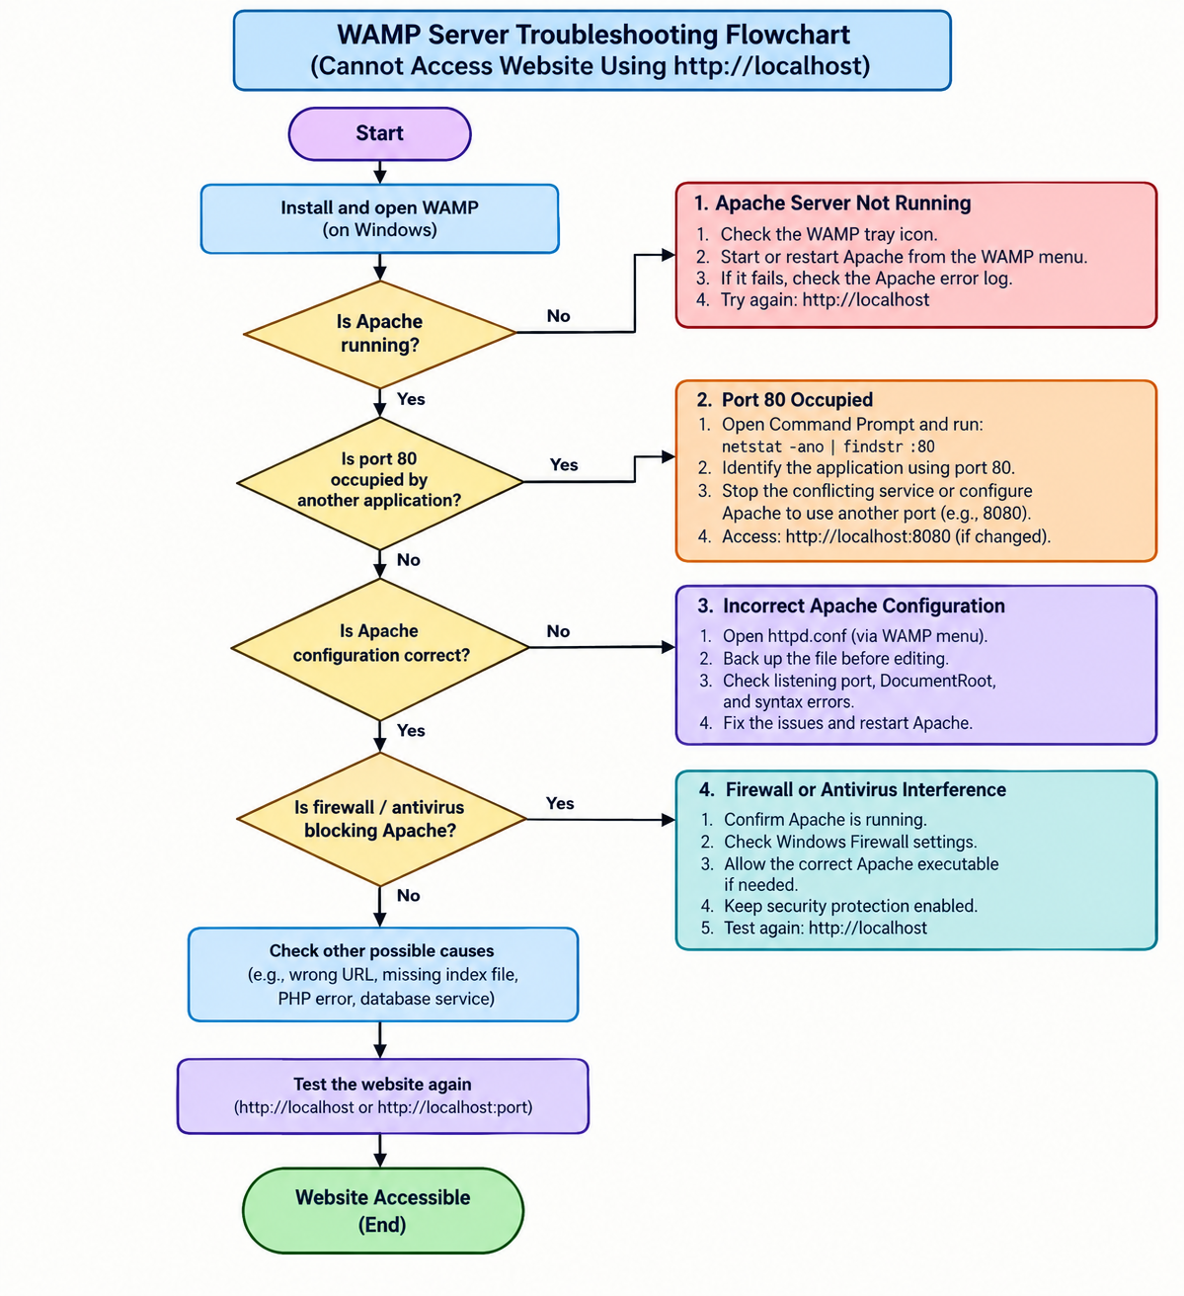

6. Additional Possible Causes
Apart from the four main causes, some other problems can prevent the developer from accessing the expected website.
Additional cause | Explanation | Solution
Incorrect URL | Apache may use a port other than 80. | Enter the correct URL, including the port number.
Incorrect website folder | Project files are outside the configured document root. | Place the project in the correct folder or configure the document root.
Missing index file | The expected index.php or index.html file is missing. | Add the correct index file and verify its name.
PHP error | Apache works, but a PHP script fails. | Check the PHP and Apache error logs.
Database service stopped | A database-backed application cannot retrieve data. | Start MySQL/MariaDB and verify the connection settings.

7. Step-by-Step Troubleshooting Summary
The developer should follow a systematic procedure instead of changing several settings at once.
Step | Action | Purpose
1 | Check the WAMP tray icon. | Determine whether services are running.
2 | Start or restart Apache. | Ensure the web server is active.
3 | Check port 80. | Identify port conflicts.
4 | Read Apache error logs. | Find startup or configuration errors.
5 | Verify the document root. | Ensure website files are in the correct location.
6 | Check firewall rules. | Confirm that the local connection is allowed.
7 | Open http://localhost again. | Verify that the problem has been resolved.

8. Conclusion
When a developer installs WAMP on Windows but cannot access a website using http://localhost, the problem may be related to the Apache service, port conflicts, incorrect configuration, or firewall and antivirus interference.
The developer should first check whether Apache is running, then verify the listening port, inspect the configuration files, and review security settings. Error logs and systematic testing help identify the actual cause without making unnecessary changes.
By applying the appropriate solution for each problem, the developer can restore access to the local website and continue developing and testing applications successfully.

Criteria | Weightage | Level 4 (Exemplary) | Level 3 (Proficient) | Level 2 (Developing) | Level 1 (Beginning) | Marks
Identification of Causes |  | Identifies all four causes correctly. | Identifies three causes correctly. | Identifies two causes correctly. | Identifies one or no causes.
Proposed Solutions |  | Provides correct and detailed solutions for all causes. | Provides solutions with minor errors. | Provides incomplete solutions. | Solutions are incorrect or missing.
Troubleshooting Flowchart |  | Clear, accurate flowchart with proper decision paths. | Mostly clear flowchart with minor errors. | Flowchart has missing steps. | Flowchart is unclear or missing.
Explanation and Presentation |  | Well-organized, detailed explanation with tables and conclusion. | Good explanation with minor gaps. | Basic explanation with limited detail. | Poorly organized or incomplete explanation.

